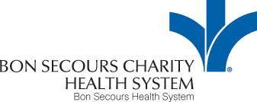

VERIFICATION OF CLINICAL ORIENTATION AND CODE OF CONDUCT

COLLEGE OR INSTITUTION____________________________________
SEMESTER AND YEAR________________________________________
COURSE TITLE AND NUMBER__________________________________
CLINICAL INSTUCTOR ________________________________________
DAY OF CLINICAL ROTATION __________________________________
TIME OF CLINICAL ROTATION__________________________________
The following students and faculty have reviewed and understand the Student Orientation Module and have reviewed the Bon Secours Code of Conduct. They hereby attest that they have read and understood the Code of Conduct of Good Samaritan Hospital. They further attest that they agree to abide by the Code as it is written. They have completed the assessment post-test and have had the ability to have their questions addressed.

NAME (PRINT) SIGNATURE DATE
1:
2:

3:

4:
5:
6:

7:

8:

9:
10:
11:

12:

FACULTY MEMBER

